Shodan Intelligence Gathering
What is Shodan?
Shodan is a search engine that constantly look for servers iot devices and webcams ,domains and open ports it gathers information continuously and it help professionals to find vulnerabilities .
Let’s get the Ip of the target :
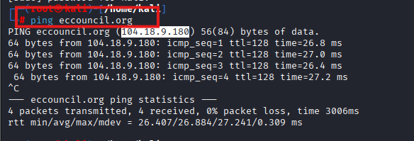

Our target is Eccouncil so we can get the Ip of the eccouncil by using
Command: Ping (Domain name ).
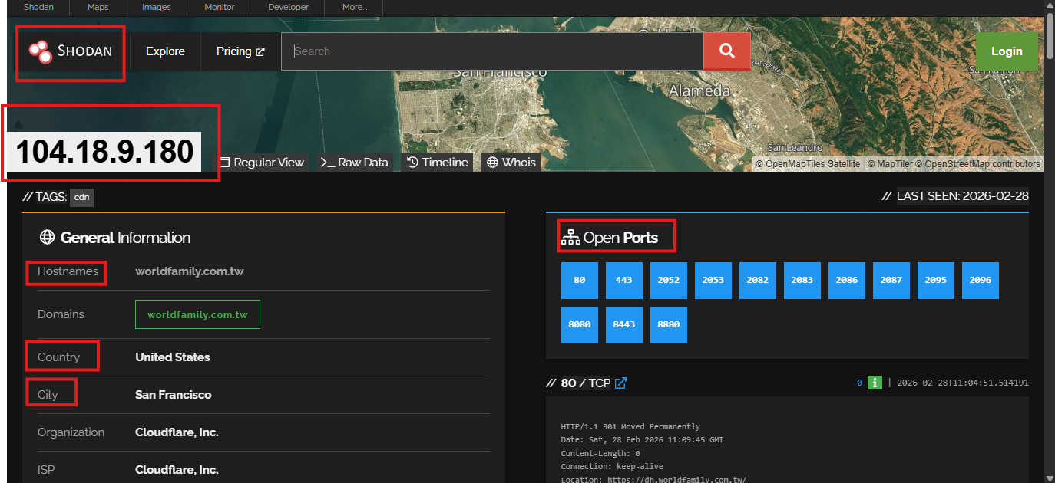

Shodan working:
By searching the Ip address on Shodan me got the following information:
- Public IP details
- Open ports
- Running services
- Technologies in use
- Possible exposed systems

Open ports:
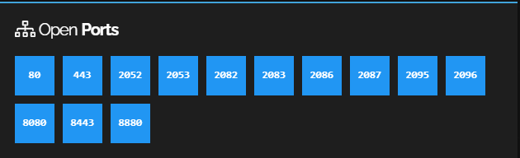
Ip details
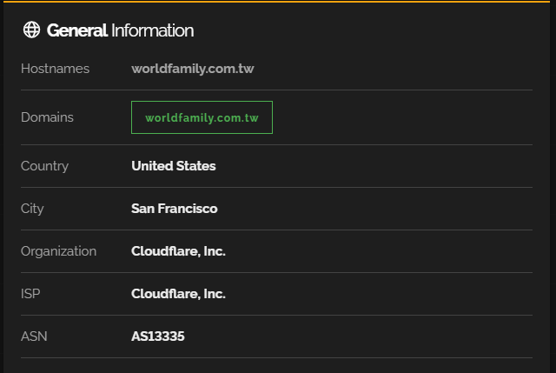
Web technologies
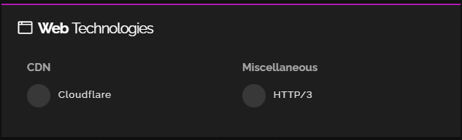

Running service

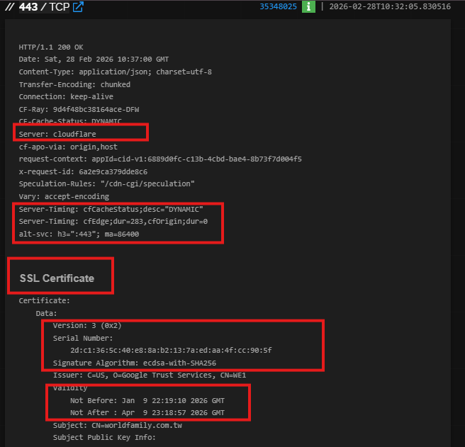

How attacker use this data?

This data can be very help full for attacker because attacker knows which ports are open and which services are running on these ports so he just has to find vulnerabilities and make his way in by exploiting the target .

